**Learn Dart with Waqar**

**Dart Inheritance:**

Dart inheritance is defined as the process of deriving the properties and characteristics of another class. It provides the ability to create a new class from an existing class. It is the most essential concept of the OOP (Object-Oriented programming approach). We can reuse the all the behavior and characteristics of the previous class in the new class.

* **Parent Class -** A class which is inherited by the other class is called **superclass** or **parent class**. It is also known as a **base class**.
* **Child Class -** A class which inherits properties from other class is called the child class. It is also known as the **derived class** or **subclass**.

**Example:**

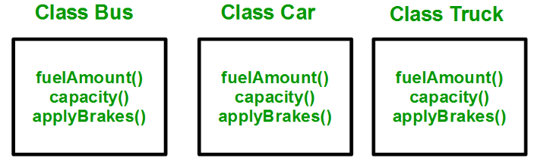

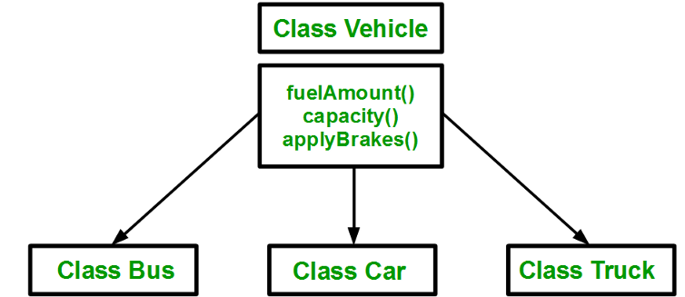

**Types of Inheritance:**

The inheritance can be mainly four types. These are given below.

* Single Inheritance
* Multiple Inheritance (**Dart doesn’t support Multiple Inheritance**)
* Multilevel Inheritance
* Hierarchical Inheritance

**Single Inheritance:**

In single inheritance, a class is allowed to inherit from only one class i.e. one sub class is inherited by one base class only.

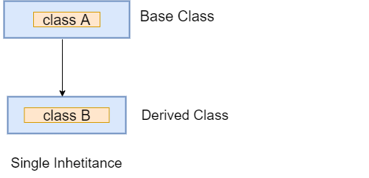

**Multilevel Inheritance:**

In the multilevel inheritance, a subclass is inherited by another subclass or creates the chaining of inheritance.

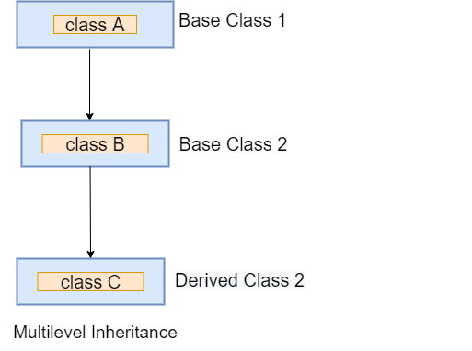

### **Hierarchical Inheritance:**

In the hierarchical inherence, two or more classes inherit a single class.

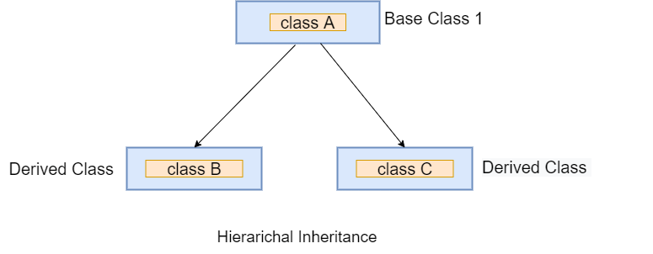

**Advantages:**

* Code Reusability
* Method Overriding
* Cleaner Code: no repetition

**Object Class:**

Super class of any class is Object. Provides default implementation of:

* toString(), returns the representation of the object.
* hashCode Getter, returns the Hash Code of an object.
* Operator ==, to compare two objects.